The Ultimate Secret to Success
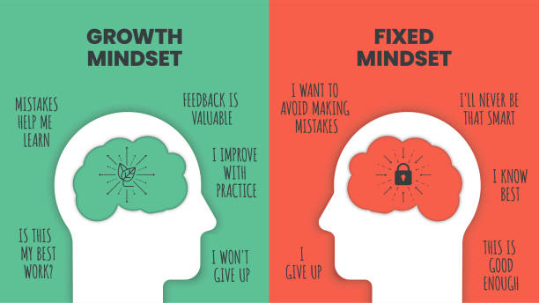

Do you feel you suck at something?
How many times did you try it out before deciding that you can't do it?
Once? Thrice?

Gosh, aren't you quite quick to judge yourself?

Here's some food for thought for you:
- We wouldn't have the light bulb if Edison had stopped after his 100th try.
- You wouldn't be drooling over the KFC bucket had Colonel Sanders accepted that his fried chicken recipe would always suck.
- One of your core childhood movies wouldn't have been Jurassic Park if Steven Spielberg had stopped after getting rejected by multiple film schools.

Earlier, you might have thought that these 3 were gifted individuals, hence, these huge achievements. But like you, at the beginning, they also sucked big time. It's only with relentless practice that were they able to build wonderful things!

In short, they had a growth mindset.

A lot of us have a fixed mindset, so here are some examples for you to catch yourself from falling into the trap and replace it with a growth mindset:

❌ You don't try new things because you are afraid of failure.
✅ You view problems as opportunities to learn new things.

❌ You believe in talent.
✅ You believe that new abilities can be developed through practice.

❌ You suffer from the tyranny of now (I should be good at painting from day 1)
✅ You imbibe the power of not yet (I am not good at painting yet...but will get better with practice)

All of this is not motivational fluff. A growth mindset is backed by science.
Our brain has neurons that communicate through connections called synapses, like tiny messengers passing electricity.
When we learn and practice, these connections get stronger, like a closer friendship. This makes the electricity pass faster between neurons, helping us think faster.
Becoming smarter by practicing a skill regularly is similar to growing muscles by consistently lifting weights.

Action Item
Whenever you catch yourself saying, "I am not good at xyz.", rephrase it to "I need more practice to get good at xyz."

